**DAILY ONLINE ACTIVITIES SUMMARY**

|  |  |  |  |  |  |  |  |
| --- | --- | --- | --- | --- | --- | --- | --- |
| **Date:** | **08-07-2020** | | | | **Name:** | **Vidya K C** | |
| **Sem & Sec** | **6th - B** | | | | **USN:** | **4AL17CS107** | |
| **Online Test Summary** | | | | | | | |
| **Subject** | **-** | | | | | | |
| **Max. Marks** | **-** | | **Score** | | | **-** | |
| **Certification Course Summary** | | | | | | | |
| **Course** | **Blockchain Basics** | | | | | | |
| **Certificate Provider** | | **Coursera** | | **Duration** | | | **4weeks** |
| **Coding Challenges** | | | | | | | |
| **Problem Statement:-1 Python program** | | | | | | | |
| **Status: Executed** | | | | | | | |
| **Uploaded the report in GitHub** | | | | **yes** | | | |
| **If yes Repository name** | | | | <https://github.com/alvas-education-foundation/DAILY_STATUS_> | | | |
| **Uploaded the report in slack** | | | | **Yes** | | | |

**Topic**:-Cloud infrastructure and service management

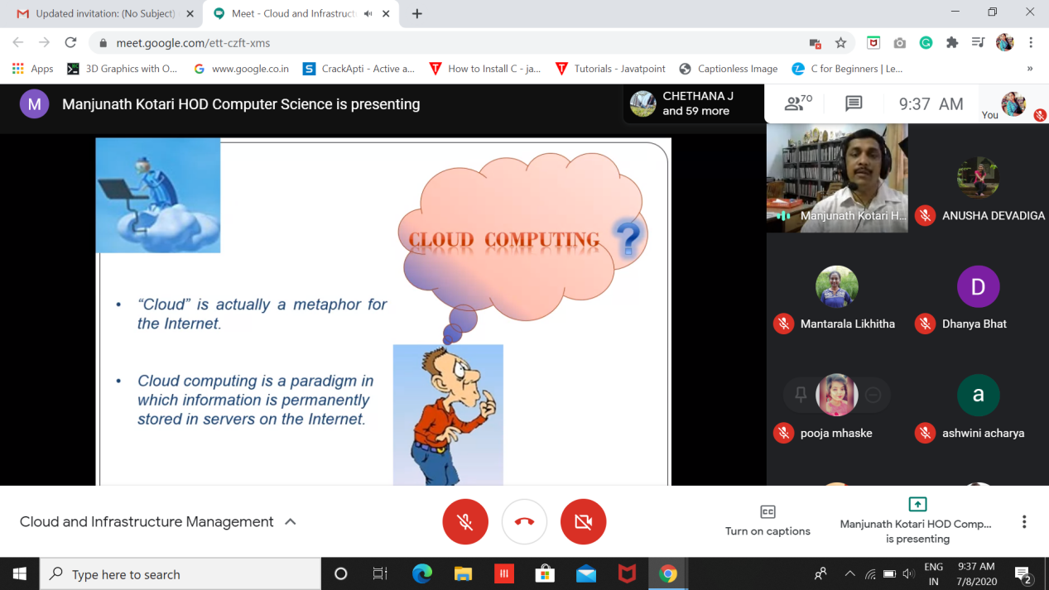

Certification Course Details: (Attach the snapshot and briefly write the report for the same)

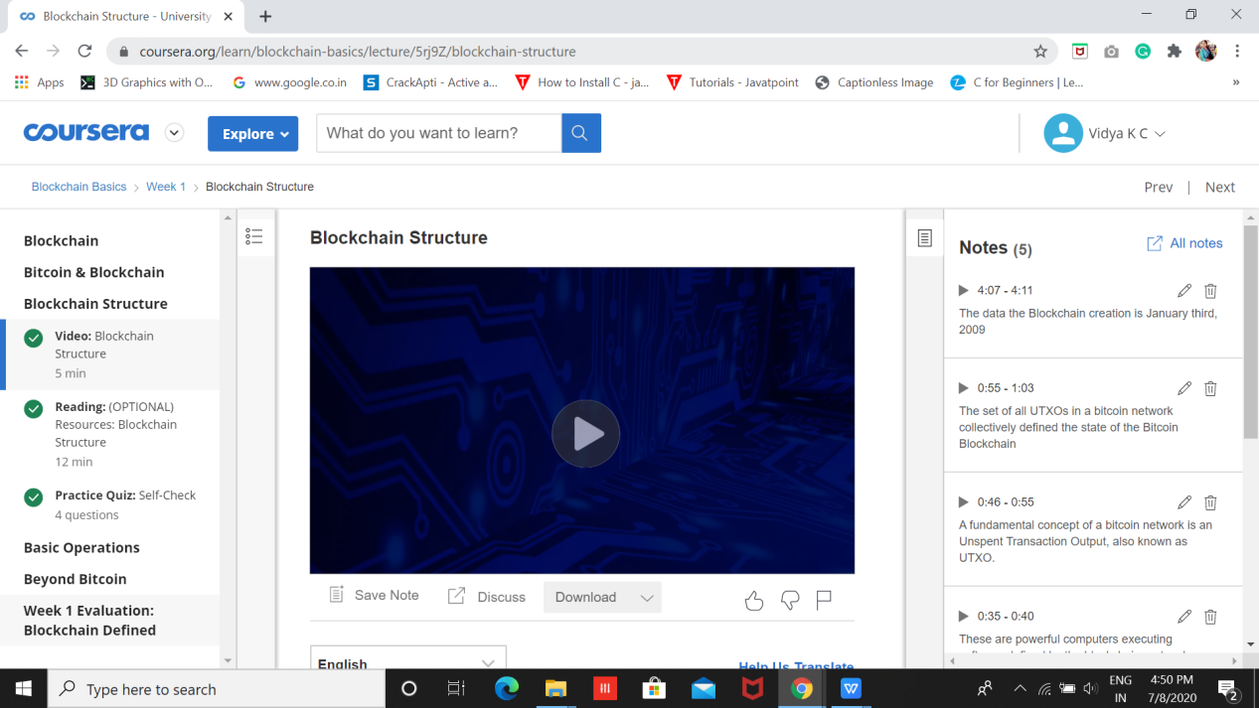

**Coding**

1. Python program for find sum of odd factors of a number

